GOVERNING BODY VISION AND AIMS
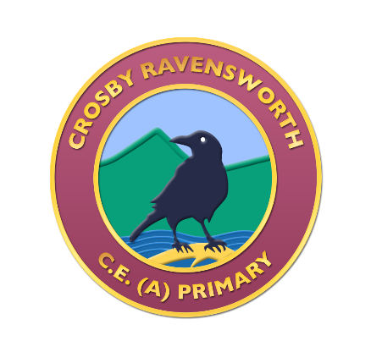

We nurture a love of learning in our safe and happy school where children flourish, ready to live life in all its fullness. Our Christian vision underpins everything we do. Our Christian values embody:
Compassion Community Courage

I have come in order that you might have life; life in all its fullness.
John 10.10

PREPARED BY: Chair of the Governors, Linda White, January 2021
RATIFIED BY: Full Governing Body, February 2021
TO BE REVIEWED BY: Chair of the Governors, January 2026

VERSION CONTROL
Version no: | Date: | Principal amendments
Version 1 | August 2015 | Initial creation
Version 2 | September 2015 | Ratification by full governing body
Version 3 | February 2021 | Review by Chair of Governors – updating of mission, logo, etc; adding of Covid comment
Version 4 | February 2022 | Noted at FGB by Governors. No changes made.

Vision
Our vision is for every child at Crosby Ravensworth Primary School to fulfil their academic and social potential, and exceed their goals in a safe and happy environment that holds Christian values at its heart.
Aims
Every discussion, decision, meeting and action of the Governors will have its focus on further raising the safety, welfare, achievement, attainment and progress of every child in the whole realm of their school life.
The Governing Body will provide support and challenge to the Head Teacher and Staff as they strive for the highest standards in all aspects of school life.
The Governing Body will support the financial performance of the school with strategic oversight, ensuring that Best Value principles are applied at all times; optimising the resources available for every member of the school community, and facilitating the best outcomes for pupils.
The Governing Body will work together strategically as it embodies and promotes the school mission statement:

We nurture a love of learning in our safe and happy school where children flourish, ready to live life in all its fullness. Our Christian vision underpins everything we do. Our Christian values embody:
Compassion Community Courage

Covid addendum:
During the global pandemic of 2020/2021, the Governing Body is supporting the Headteacher, Staff and School Community with a combination of frequent contact via Zoom and telephone calls. We are continuing to challenge the Headteacher and Staff over the safety, welfare and provision of education to our pupils, whilst being mindful of their welfare and safety. We strive to provide a strong and supportive response wherever it is needed.

