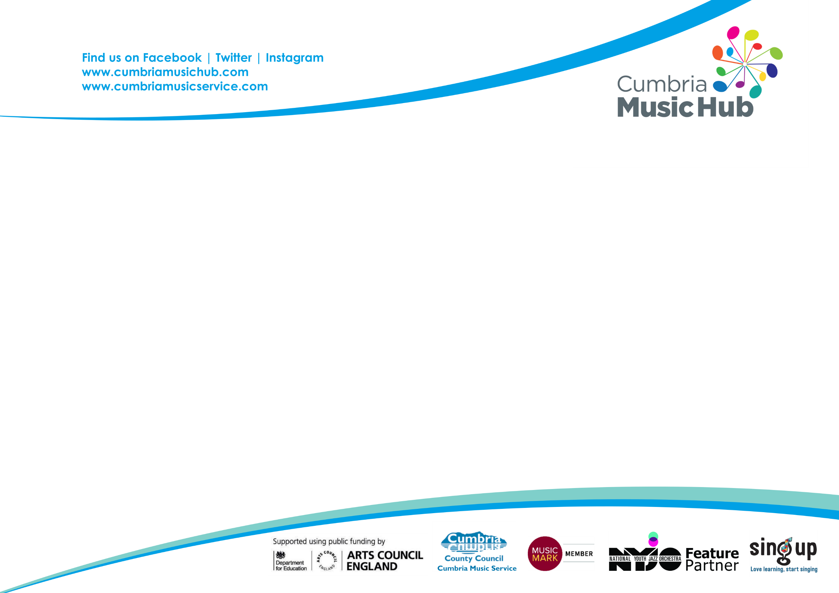

School Music Education Plan 2021 - 2022
MIDAS Visit
Music Improvement, Development and Support

School: Crosby Ravensworth CE Primary

Cumbria Music Education Hub acknowledges the original document produced by Sefton and Knowsley Music Hubs for use by North West Music Hubs

Cumbria Music Education Plan 2021 - 2022

Cumbria Music Hub Goals
- To inspire children and young people to develop a love of music through participation in a range of musical experiences within and outside school.
- To develop the talents of children and young people engendering a lifelong passion and desire to participate in musical and cultural events, opportunities and experiences.
- For children and young people to gain an appreciation of the contribution the different musical genres make to culture and communities around the globe.

Aims
- To help schools evaluate their musical provision accurately and plan for its development.
- To provide access to targeted follow-on support on a bespoke basis for each school based on their own areas for development.

Outcomes
- A set of bespoke music development recommendations drawn up in partnership between the Hub practitioner and the school.
- An offer of follow-on support from Cumbria Music Hub in order to address these recommendations
- For senior leaders: a greater understanding of best practice in music, and more accuracy in appraising music in their school

A: How does your school deliver a progressive music curriculum for all pupils?
Curriculum | 1. Embedded | The music curriculum is well sequenced and incremental. All pupils are clearly offered the opportunity to develop their technical, constructive and expressive knowledge through a range of inclusive and creative musical activities. These activities must be practical (using instruments and ICT) as well as vocal with composition tasks and improvisation firmly embedded.  The activities should be led by confident deliverers who have been provided with opportunities for upskilling and training from the Music Lead or outside deliverers.  The school is aware of the new Model Music Curriculum, the National Plan for Music Education and is clearly engaging with these. There is a clear curriculum map / learning journey in place.
Curriculum | 2. Established | There is a music scheme in place which is meeting national expectations that is adhered to across all Key Stages. There is evidence within that curriculum of interrelated activities that lead to musical understanding (technical, expressive & constructive). There is evidence of incremental learning.  All pupils  - Participate in weekly practical curriculum musical activity  - Use ICT effectively, musically and creatively
Curriculum | 3. Emerging | The music curriculum covers the minimum national expectations. There is a scheme in place however there is not enough evidence that it is incremental, and delivery across both Key Stages is inconsistent.  - There is evidence of regular vocal work  - ICT is rarely used to support musical activities  - Composition or improvisation are not offered as a regular part of learning for all pupils
Embedded |  | Established |  | Emerging
Duncan as the Head has always strongly lead music within the school. Previously using the Charanga scheme as a progressive curriculum resource. Now, Charanga is used as the basis for pupils learning journey and the programme is followed as suggested. For KS2 Duncan now adds in Freestyle units of work to embrace the composition elements of the National Plan and intends to explore the “Build your own Scheme” option through Charanga so that the learning map is clear and obviously incremental.

In addition, Duncan is very interested the First thing Music scheme for EYFS and KS1 and would like to explore this option this year. Development for this age group has been set a s performance management objective.

B: How do you collate evidence of incremental learning?
Assessment | 1. Embedded | Each class teacher has a knowledge and a record of pupils’ previous/current musical interests and experiences.  - All teachers record audio/video evidence of a variety of elements of the curriculum to form a basis of incremental evidence across the curriculum.  - Teachers can identify where students are in their learning journey.  - Pupils engage in peer assessment and record some of their own work in order to identify their own progress in music.  - Pupils celebrate their achievements in their learning through regular verbal reviews/plenary sessions that are recorded and uploaded to a central place.  - Visiting teachers keep accurate records of pupil attendance and liaise with the Music Lead about their pupils. They also offer video or audio progress to contribute to pupil records.  - Pupil progress is reported to parents annually
Assessment | 2. Established | The school is aware of pupils’ previous musical interests and experiences, and pupils’ starting points are clearly defined.  - The use of audio and video recording is a feature which supports the evidence of a progressive and incremental curriculum.  - Visiting teachers keep accurate records of pupil attendance and progress.  - Pupils are able to identify the progress they have made in their music making and have evidence of this
Assessment | 3. Emerging | Evidence of recording of work is present but it is not centrally collated in order to provide a more formal recording of progressive evidence. It occurs infrequently during the school year.

Embedded |  | Established |  | Emerging
Elements of assessment are very much in place (recordings etc) and the staff know the starting points of every child and the progress they make due to the nature and size of the school. However, recording and tracking Pupils evidence of progressions could be more systematically done, in order to show that all aspects of the curriculum are being embraced and enjoyed.

C: What opportunities are there for pupils to be involved in musical performance?
Performance | 1. Embedded | All pupils are participating in and are exposed to a wide range of performance opportunities. Music clubs are offered to enrich curriculum learning, or children can engage independently online through resources such as YUMU.  External links are enhanced by pupils regularly attending regional, community and Hub musical activities. Music plays an important role in school life, and as a result the subject makes a strong contribution to pupils’ cultural capital and personal development.
Performance | 2. Established | Performing is at the heart of much musical activity and learners are given every opportunity to experiment with instruments as well as voices and to experience making music with others on at least one other platform outside of school (even if this has been online in the past year).  - Most pupils are participating in a range of performance opportunities. Pupils are able to identify the progress they have made in their music making and have evidence of this
Performance | 3. Emerging | There is evidence of some performance activity, with an attempt to develop pupils’ confidence, expression and social interaction through music making.

Embedded |  | Established |  | Emerging
April: Arts entertainment evening (well attended) Performance of poetry, dance Music (recorder) evidence on school website
Arts Mark award (lots of visiting artists)
Christmas Carol singing (elderly lunch club,) Tebay, & Retirement home in Penrith
End of Year leavers service
Eden Big Sing
Transition Sing (Big Play prep)
Community lunches
Cultural Capitol: eg visiting Sunbeams to see a Brass Quartet (will record children’s responses after this)

D: How does your school review and support curriculum music provision? Is there access to training for all staff as well as external music making opportunities for pupils where good practise can be shared?
Review and Vision | 1. Embedded | Music is held in high regard within the school and resources are used to the full, supporting evidence of high quality outcomes, as well as offering excellent value for money.  The Music Lead supported by the Headteacher/leadership team is able to demonstrate an effective partnership. Staff make use of regular training and upskilling opportunities and good practise in music is shared with all colleagues.  The Music Lead has a statement of intent and impact, and all stakeholders have knowledge of this.
Review and Vision | 2. Established | There is an established link between the Music Lead and the Headteacher/school’s leadership team, ensuring that both have a good subject knowledge and understanding. Staff have access to training and support.  Music is given equal balance in terms of resources and time as other foundation subjects on the curriculum and the timetable reflects this.  The Music Lead is encouraged to engage in partnership activities in order to continually develop and share good practice.
Review and Vision | 3. Emerging | There is some evidence of the impact of self-evaluation on music provision designed to meet the needs and interests of all groups of pupils. There is insufficient time for the subject which is hindering the use of resources. Value for money is not evident.  The school is in the process of developing a vision for music. Training opportunities are not yet taken up by all staff.

Embedded |  | Established |  | Emerging
Duncan is an enthusiastic and skilled deliverer whose passion for music is shared with his colleagues, ensuring the best outcome for all pupils within the school. He has a strong vision and continually looks for ways to develop and enhance his music programme.

Training online (Charanga)
Early ears development

Friends of the school provided new set of recorders and music well supported

Charanga online CPD available to staff

E: How closely does your school work with the Hub as outlined in the National Plan For Music Education?

Engagement with Cumbria Music Education Hub | Do you complete your annual data return for Cumbria Music Hub?  Yes
Engagement with Cumbria Music Education Hub | Do you look at our website regularly, our Facebook pages, Insta or Twitter?  Hub facebook page (request to join Cumbria music hub Primary teachers page)
Engagement with Cumbria Music Education Hub | Which CMEH offers, music delivery, events or training do you regularly take up or attend?  Is anything new to you this year?  Big sing events
Engagement with Cumbria Music Education Hub | What if CMEH packages or CPD would you like us to contact you about in the future?  First Thing Music Programme & possibly Live Music Now
Engagement with Cumbria Music Education Hub | What Hub, Regional (in partnership with the Hub) or National events-such as Young Voices, will you be taking part in this year?  Possibly Big Sings

MIDAS Review Summary Sheet

Name of school Crosby Ravensworth Primary Date of Review 26/9/22

DFE No 909 3356

Reviewer Sarah Devereux

School Contact Name and email: Duncan Priestley <head@crosbyravensworth.cumbria.sch.uk>

Complete the table based upon the MIDAS review document.

Please tick as appropriate

 | A  Curriculum | B  Assessment | C  Performance | D  Review and Vision
Embedded
Established
Emerging

Recommendations

Recommendations for the School (up to 4)
- To create a learning map/progressive overview of the curriculum journey of pupils from EYFS to Yr6. We discussed using “Build your own scheme” on Charanga (Free training available online through Charanga – see CPD section)
- Assessment: collating evidence through simple video clips in order to show progression: For example: KS 2 recording feedback (discussion) about performances they have taken part in or been to see, composition tasks, improvising, recorder group start of the year (first piece learnt in the autumn term and then later in the year – March and July). For EYFS & KS1 recording snippets of warm up activities at the start of the year – for example, moving to a pulse, copying rhythms, and then later in the year accompanying a song including the use of tuned percussion (chime bars eg Big Bear Funk), answering baseline quizzes from Model Music Curriculum scheme. Clapping “shape” patterns from the rhythm grids in the Freestyle creative apps section, doing an activity from First thing music.

Any recommendation for the Music Hub

Very keen to be part of the First Thing Music programme and School Performance management objectives will be based around this this year.

Useful Websites

Cumbria Music Education Hub
www.cumbriamusichub.com/
www.cumbriamusicservice.co.uk
@cumbriamusichub Twitter | Facebook | Instagram

Music Mark
www.musicmark.org.uk/

Arts Council England
www.artscouncil.org.uk/

Model Music Curriculum

https://assets.publishing.service.gov.uk/government/uploads/system/uploads/attachment_data/file/974358/Model_Music_Curriculum_Key_Stage_1__2_FINAL.pdf

National Plan for Music Education
www.gov.uk/government/publications/the-importance-of-music-a-national-plan-for-music-education

Curriculum and the New Education Inspection Framework
www.gov.uk/government/speeches/hmci-commentary-curriculum-and-the-new-education-inspection-framework ‎

Useful Contacts

Marion Hinds - manager of Cumbria Music Service/Lead organisation for Cumbria Music Hub marion.hinds@cumbria.gov.uk
Amanda Wright – MIDAS lead amanda.wright@cumbria.gov.uk
Sarah Devereux – Assistant Hub Lead S Lakes/Eden/Furness sarah.devereux@cumbria.gov.uk
Based on a document which has been developed collaboratively between Sefton and Knowsley Music Hubs and made available for use by North West Music Hubs; adapted by Cumbria Music Hub.

